Analyzing Swiggy

High Level Document

Document Version Control

|  |  |  |  |
| --- | --- | --- | --- |
| Date Issued | Version | Description | Author |
|  |  |  |  |
|  |  |  |  |
|  |  |  |  |
|  |  |  |  |
|  |  |  |  |

Contents

Document Version Control………………………………………2

Abstract…………………………………………………………..4

1. Introduction……………………………………………………4

1.1 Why this high level design document?....................................4

1.2 Scope…………………………………………………………5

2. General Description…………………………………………...5

2.1.Product perspective and problem statement…………………5

The online food ordering market includes foods prepared by restaurants, prepared by independent people, and groceries being ordered online and then picked up or delivered. In this project , the following aspects of swiggy and its behavior is uncovered using business intelligence.

2.2.Tools used……………………………………………………5

3. Design Details…………………………………………………6

3.1.Functional Architecture……………………………………...6

3.2 Optimization…………………………………………………7

4. KPI’s…………………………………………………………..7

4.1 KPI(Key performance indicator)…………………………….7

5. Deployment……………………………………………………8

**Abstract**

The online food ordering market includes foods prepared by restaurants, prepared by independent people, and groceries being ordered online and then picked up or delivered. The first online food ordering service, World Wide Waiter (now known as Waiter.com),was founded in 1995. Online food ordering is the process of ordering food from a website or other application. The product can be either ready-to-eat food or food that has not been prepared for direction consumption.

The project unfolds the hidden insights from the data and discover the behavior patterns of swiggy.

**1. Introduction**

1.1 Why this High Level Design Document?

The purpose of high level design document is to implicate the details of the project description for creating model suitable for coding. This document is used to detect various issues while coding and also it can be used as a reference to determine the interactions between the modules.

The HLD will:

1. Presents all the design aspects covered in detail

2. Describe the user interface

3. Describes the hardware and software interfaces

4. Describes the performance requirements

5.Describes the design features and architecture

1.2 Scope

The HLD documentation used to give the structure of the system in terms of application design , application flow and etc. The HLD uses the non technical and mid technical terms which can be understood by anyone who uses the system.

**2. General Description**

2.1 Product Perspective and Problem Statement

The online food ordering market includes foods prepared by restaurants, prepared by independent people, and groceries being ordered online and then picked up or delivered. In this project , the following aspects of swiggy and its behavior is uncovered using business intelligence.

Using the techniques of data visualization and powerful features of Power BI to uncover the hidden insights from the data to determine the patterns and hidden information of the data.

2.2 Tools used:

1. Pandas

2. Excel

3. Power BI

4. Seaborn

5. Pandas Profiling

**3. Design Details**

3.1 Functional Architecture

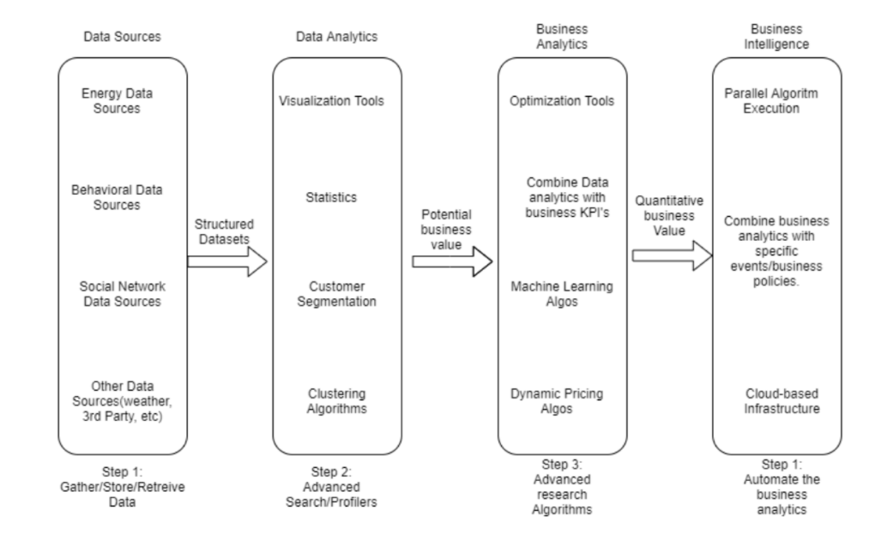

Working of Business Intelligence

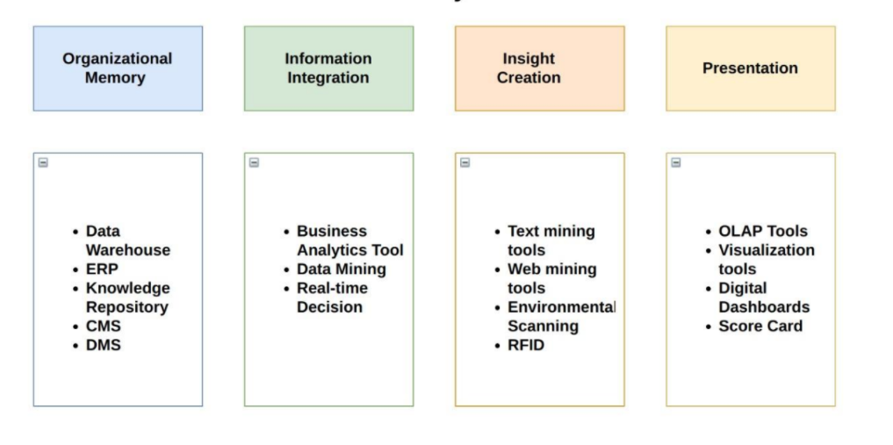

3.2 Optimization

Data performance:

1. Remove unwanted columns

2. Remove the unwanted rows

3. Optimization increases the speed and performance of search queries.

Reduce the data:

1. Reduce the dimensions of the data

2. Filter the null values

3. Filter the missing values

Data types

1. Change the type of the column for the defined type.

2. Check the values and its consistency

Optimize the calculations

1. Derive the columns as per the business requirement

2. Define the data type as per the data in the column

3. Use aggregate operations like min , max , count and etc to filter the values from the dataset and derive the insights from the dataset.

4. Use the groups to filter the values and derive the results from the data.

**4. KPI**

Dashboards will be implemented to display the key performance indicators for deriving the results and hidden insights from the data.

The dashboards will include the charts and graphs with the slicers and filters to filter the values and to observe the patterns in the dataset.

4.1 KPIs(Key performance indicator)

Key indicators displaying the summary of the swiggy outlets in Bangalore city with different measures

1. Impact of Ratings in the cuisines

2. Ratings of the cuisines with their ratings and their maximum cost.

3. Ratings of the cuisines with their ratings and their minimum cost with the location as filter.

4. Shops with their ratings and other details like cost , ratings , cuisines with the location as a filter.

5. Influence of cuisines in the minimum ratings and shop ratings

6. Influence of locations in ratings of the cuisines

**5. Deployment**

The data and analytics are the main part for discovering the insights from the data and determining the hidden information from the dataset. Power BI supports varied options of deployment like as a file share , Power BI service , cloud , hybrid infrastructure and sharepoint etc.

Advantages:

1. Access to volumes of data from varied sources

2. Interactive features and visuals to create reports and dashboards

3. Real time analytics

4. Actionable insights and visuals.

Features:

* Interactive visuals
* Supports varied data sources
* Power Q-A to explore more about the data
* Easy to use filters
* Actionable insights
* Easy to integrate

Products:

Power BI desktop

- Used for power query , power view , power pivot for developing and driving analysis and insights from the data.

- Used to create reports and stunning dashboards

Power BI service:

- Data preparation and reports are in Power BI desktop.

- Reports and dashboards are published in Power BI server

Power BI dashboard:

* Used to insights data from the dataset
* Used to generate dashboards from the reports
* Single page dashboard is known as canvas
* Reports can be published to Power BI dashboard using Power BI service.
* The visuals in the reports are known as tiles.